Module End Assignment
Data Cleaning,Analysis & Visualization With Excel

Fathima Sabeeha T
Batch=B69
Step 1
Data dowloaded and open in excel sheet

Step 2
Data cleaning process
No duplicate found .There is lot missing value ,in customer_dim table there 4 missing in loyality level coloumn ,to find missing cell syntax==COUNTBLANK(A2:H501) THEN Home tab-edit-go to -blank,so we got the blank cell
H2,H20,H29,H39 In This cell replaced with most frequent word platinum
In Product dimthere 9 missing table . methode to find blank
=COUNTBLANK(A2:G101) missing values are in table cost and stock it is numerical so we found median and apply
In cellF4,F20,F25,F29,F49,F85 Replaced with median of cost
Syntax=
=MEDIAN(F2:F101)=242.965
In table of stock G13,G22,G57 REPLACED with median of cost
=MEDIAN(G2:G101)=276
Missing values In sales fact table in table quantiy=5unit price=3 discount=4 total amount =5 missing values. This are numerical data so replaced with median of table

Find United states of America replaced with USA

usa replaced USA

Change custmor id c- to CUST
Same with P- with PROD

Step 3
To remove entire column of sub_category select the coloumn then right click select delete and choose entire coloumn
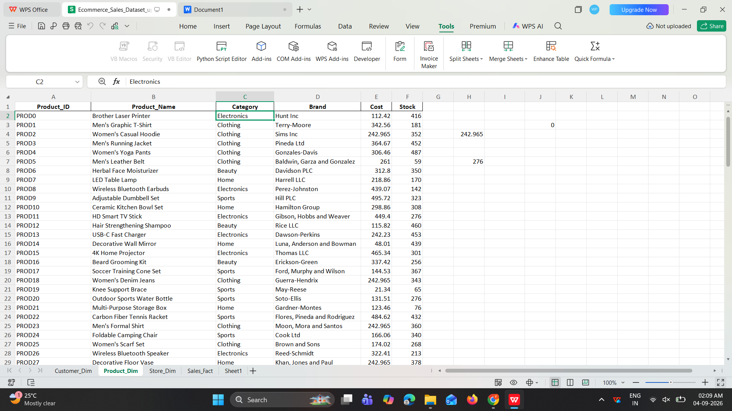

Step 4
IN EXCEL FORMULAS& FUNCTION SHEET

Excel function -(1) sum
Totaql cost =SUM(Product_Dim!E2:E101)
Total stock =SUM(Product_Dim!F2:F101)

(2)IF function
=IF(Sales_Fact!J1:J2001>=500,"good","bad")

(3)Count if
Total number of female
=COUNTIF(Customer_Dim!D2:D501,"Female")
Total number of male
=COUNTIF(Customer_Dim!D2:D501,"Male")
(4)Average of amount
=AVERAGE(Sales_Fact!J2:J2001)
- TEXT Functions
=proper(usa)=USA
- Xlookup
For get theTital amount of customer CUST1276
=XLOOKUP(Sales_Fact!C18,Sales_Fact!C1:C2001,Sales_Fact!J1:J2001)
Excel analysis
Median of total amount
=MEDIAN(Sales_Fact!J1:J2001)
Mode of discount
=MODE(Sales_Fact!H2:HJ2001)
Standerd deviation of sale
=STDEV(Sales_Fact!J2:J2001)
Minimum amount
=MIN(Sales_Fact!J2:J2001)
Maximum amount
=MAX(Sales_Fact!J2:J2001)

TO Cmbine two table iam using vlookup function

FOR adding category in sale fact data from product dim
=VLOOKUP($B2,Product_Dim!$A$1:$C$101,3,FALSE)
For store region
=VLOOKUP($D2,Store_Dim!$A$1:$C$21,3,FALSE)

Pivot Table
TO Create pivot chart we select combined data and in insert tab then select pivot table then choose row and coloumn

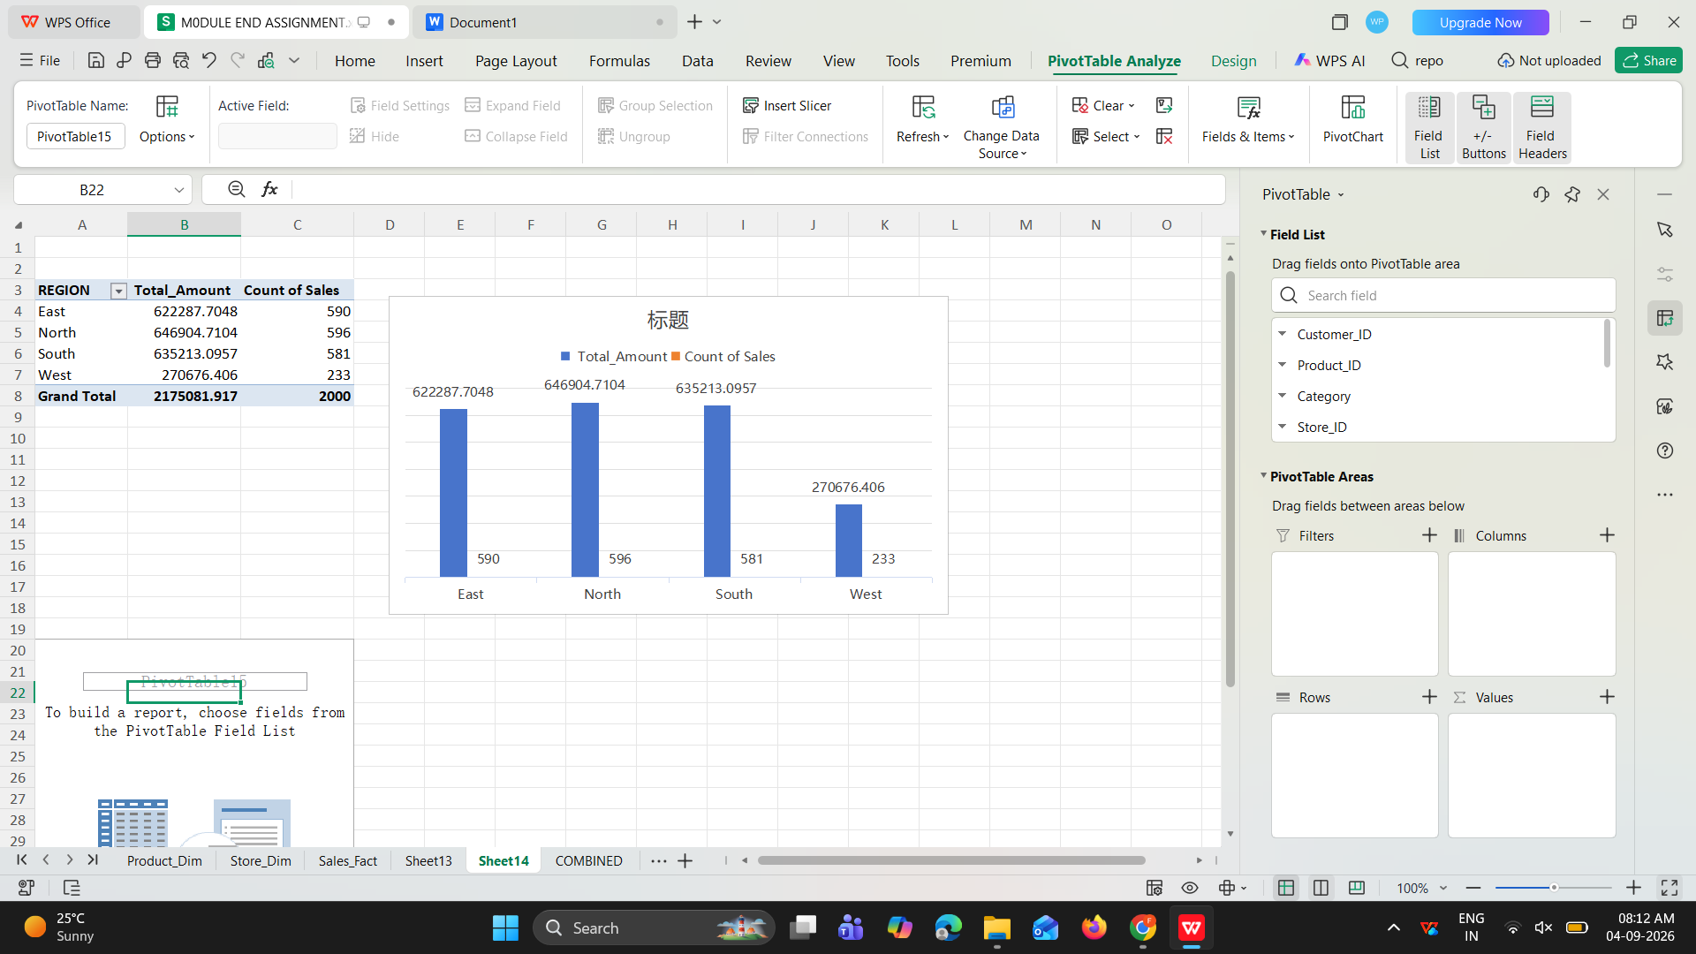

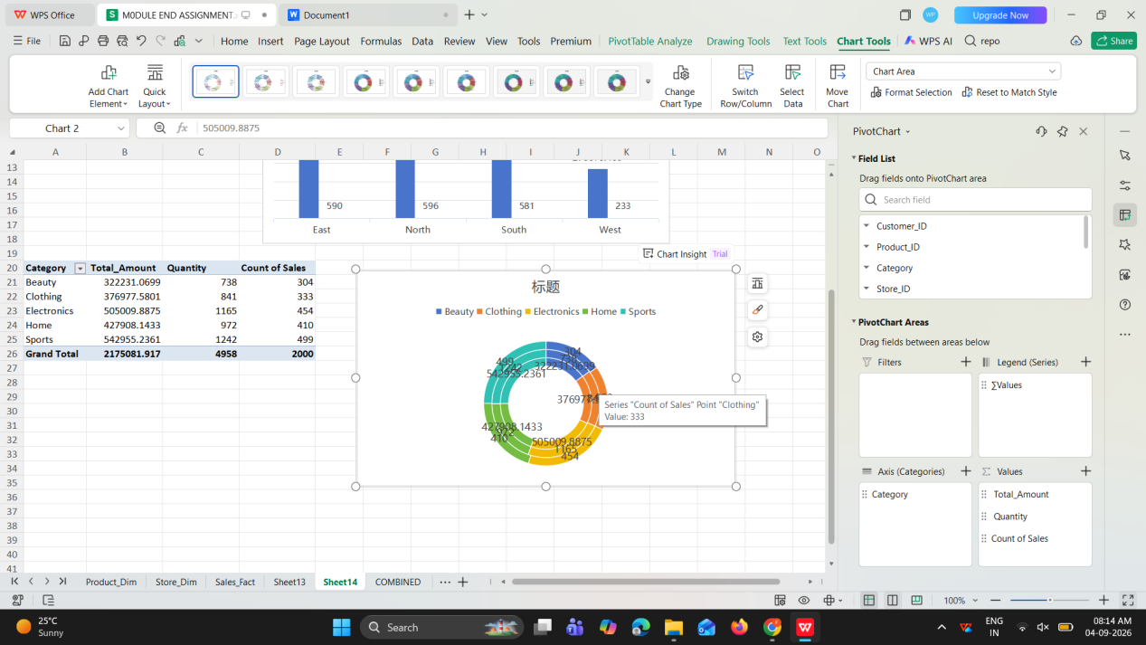

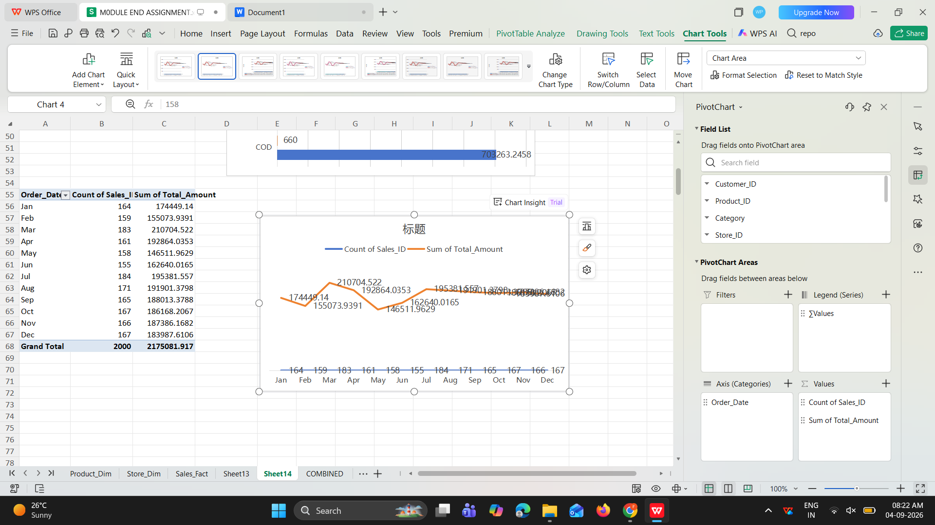

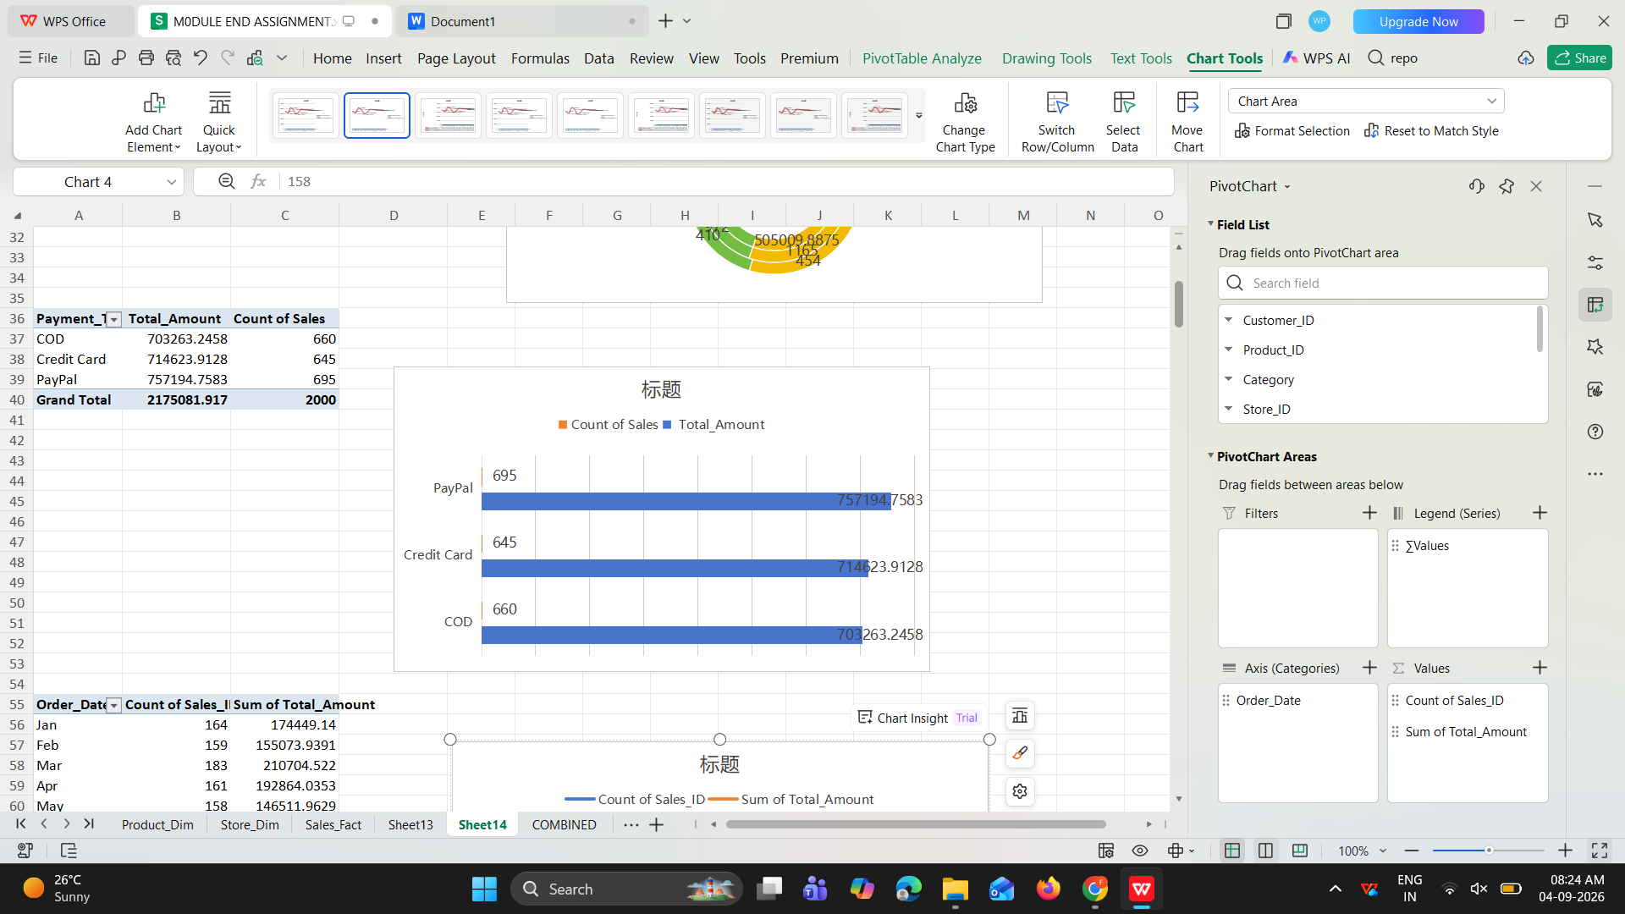

Intractive dashboard
For pivot table and pivort chart we copy paste from excel sheet pivot table then we add slicer.select pivot table then insight slicer then paste dashboard then click the report connection
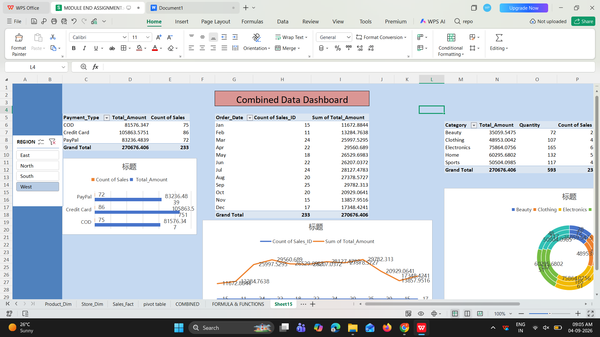

Summary

To analyse the data in excel there is lot of option.to cleaning the data duplicate remove ,standardization the text , handle the missing values with median or mode and delete inconsistant data. In sales table total sales are =SUM(J2:J2000)
= 2174212.937
In 2000 orders.the category summary shows thathighest sale category and provides order comparison of all categories.region and payment summaries compare sales performance and order counts across operating regionsa and payment methods.pivot charts helps the visualisation of data .payment pivot chart shows credit card method is most used.monthly date pivort chart shows which month has highest sale .in category wise elactronics product most saled

